Friday, 17 June 2016

Avior Developer Interview Project

Overview

This document outlines the requirements for a project to test basic C# / SQL Server abilities. If you are viewing this doucment, then you must already have forked the project from our GIT repository. You should see the following directory structure

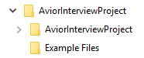

The C# project template that you will need to complete is in the AviorInterviewProject folder. The Example Files folder contains the files that your code will need to parse and insert to a DB.

Candidates are expected to complete the project as outlined below, and upload these to an online GIT repository (e.g. Github). The project will be used as a discussion point in a techical interview that follows.

The Project

The goal of the project is to write code to parse data in a collection of Excel files and insert these data to a SQL Server database. A project skeleton has already been created for you as well as the table in a SQL Server database that is hosted via Amazon Web Services (AWS).
The project begins with the following structure
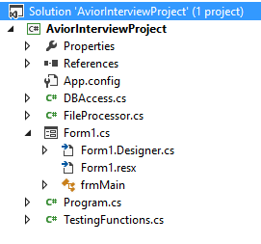
We recommend that you place your code in a new separate class file, but if you feel you would create better code by altering the existing files then you may do so as well.
You should be able to complile and run the project as soon as you have forked it. It should look like this when you run it:

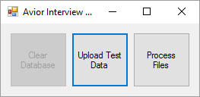

Your task will be to implement the Process Files button. But more of that later.
Accessing the database
The DBAccess class contains the connection string to the DB set up for you. You need to alter the connection string to use your name. So for example if your name is Harry, then change the following code from
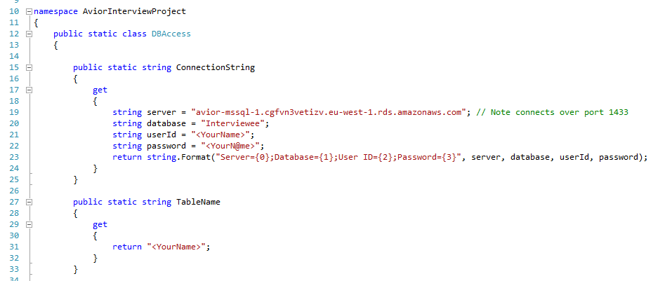

To
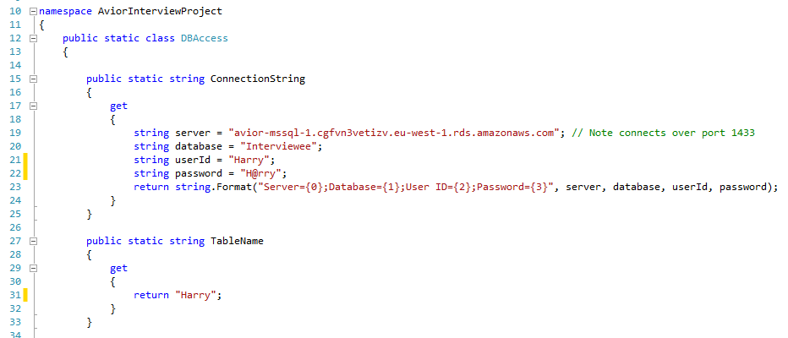

I.e. replace all 3 instaces of <YourName> with your name (Use an ‘@’ instead of the first ‘a’ in your name for the password). Note the altered lines are marked with a yellow stripe by the line number in the miage above.
The DB user created for you has SELECT, INSERT and DELETE permission to your table only. The is also a stored procedure called dbo.Clear<YourName> (so dbo.ClearHarry in our example) that you can use to empty your table during testing if you wish, but you also have DELETE permissions so you could clear the table any way you perfer. You will see a disabled clear table button in the application. You can enable this button and link it to a function to clear the table for your own testing purposes if you like, but this is not a requirement of the project.
The Upload Test Data button is linked to the TestingFunctions.InsertTestData() function. This function will insert test data to your table. You can use it to make sure you are able to connect to you database. Note that we have implemented a bulk insert function for you already in DBAccess.BulkInsert(). Simply pass it your connection string, table name and your data in a DataTable data-structure. You can see an example of this at the end of the TestingFunctions.InsertTestData() function.
If you have errors uploading to the database, make sure that your firewall is allowing traffic over the 1433 port. Either add a rule to open this port or temporarily turn off your firewall when inserting to this database.
Another potential pitfall is that AWS requires your IP addess to be whitelisted. It’s possible that your external IP address won’t be static in which case you will have to communicate with Dan at Avior Capital Markets about this issue. His contact details are at the end of this document.
Note that even if you are set up correctly, ou might still occassionally get the error
A network-related or instance-specific error occurred while establishing a connection to SQL Server
If you do encoutner this error, simply run your code again. Sometimes it takes a couple of tries to establish the connection.
Your Task
Your task is to process 32 SAFEX Options Traded files in the Example Files folder and insert their data to the database. The files look like this
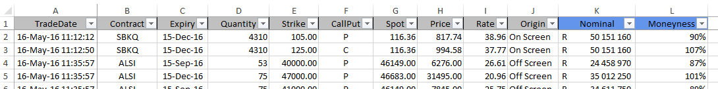
The database table is already set up for you and has the following schema
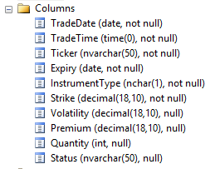
You should notice that the schema does not has attributes for the last two columns of the data i.e. Nominal and Moneyness as wel as for Spot (column G). You do not need to upload these columns to the database and can ignore them completely. Use the following column mapping:
- TradeDate comes from column A, TradeDate. Use only the date, exclude the time.
- TradeTime also comes from column A, TradeDate. Use only the time exclude the date.
- Ticker comes from column B, Contract
- Expiry comes from column C, Expiry
- InstrumentType comes fom column F, CallPut. This should be a single uppercase character, “P” or “C”
- Strike comes from column E, Strike
- Volatility comes from column I, Rate
- Premium comes from column H, Price
- Quantity comes from column D, Quantity
- Status comes from column J, Origin
Note that some of the data in the files has been intentionally manipulated. You should not make any manual corrections to the files but rather correct for these inconsitancies programmtically. In other words, you code needs to be robust to certain inconsitancies with the files.
If you get completely stuck dealing with an inconsistant file, then add a line in your code to skip over that file.
You may use any method you please to read the files and place the data in a DataTable. You should make the DataTable has the same structure as the DB table schema. You can see an example of this in TestingFunctions.InsertTestData(). However, you may prefer to create your table in some other way such as LINQ2SQL, the choice is yours. You might find the extension method included in DBAccess, ToDateTable(), useful to convert a List<> to a DataTable depending on what method you end up using.
Other
You are welcome to, but not required to, alter the winforms interface anyway you choose. You might find it useful to provide yourself with some sort of upload progress for example. But this is not necessary, it is only an option if you feel it will ease the development process for you.
Contact
You are welcome to contact Dan Golding at Avior Capital Markets with any questions related to this project. You can reach him on 021 440 5964 during office hours or 072 340 5853 after hours or email him at dan@avior.co.za.

